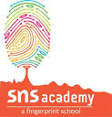
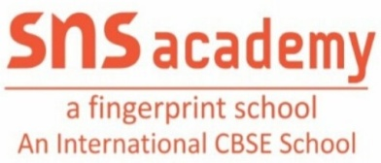
EVS - ORAL

1. I like to help other people. I help to put out fire. Who am I ?
Ans : Fireman / Firefighter
2. I work at Hospital.I help people get better.I can give them medicines.Who am I?
Ans : Doctor
3. I work at a School.I teach students.I help students learn new things.Who am I?
Ans : Teacher
4. I drive a bus. I help people to get around town easily.Who am I?
Ans : Driver
5. I work for people. I help people to find things,when they lost it.Who am I?
Ans : Policeman
6. I work for people. I wear a uniform. I deliver letters and cards to people.Who am I?
Ans : Postman
7. Which part of the plant absorbs water ?
Ans : Root
8. Which part of the plant prepares food?
Ans : Leaf
9. Many petals makes _____________
Ans : A Flower
10. Leaf prepares food with the help of ______________________
Ans : Sunlight
11. Which part of the plant supply water to leaf?
Ans : Stem
12. Name the part of plant which starts with letter ‘B’?
Ans : Buds
13.Which is our National Flower?
Ans : Lotus

14. Which is our National Bird?
Ans : Peacock
15. Which is our National Animal?
Ans : Tiger
16. Which is our National water animal ?
Ans : Dolphin
17. Which is our National Fruit ?
Mango
18. Which is our National Currency ?
Ans : Rupee
19. Which is our National Tree ?
Ans : Banyan Tree
20. The National Flag of India is ?
Ans : Tiranga
21. Which organ pumps the blood throughout the body?
Ans : Heart
22. Which organ helps in digestion of Food ?
Ans : Stomach
23. Which organ helps us to breathe?
Ans : Lungs
24. Which organ helps us to think?
Ans : Brain
25. Which organ helps to remove waste as urine from our body?
Ans : Kidney
26. Which sense organ help us to Taste food? Ans : Tongue
27. Which sense organ help us to see? Ans : Eyes
28.Which sense organ helps us to hear ? Ans : Ears
29. Which sense organ help us to feel? Ans : Skin
30. Which sense orgsn help us to smell? Ans : Nose

